Understanding Test Cases in Manual Testing

Types of Test Cases
Test cases are not one-size-fits-all. Different types serve different purposes within a testing programme, and knowing which type to write for a given situation determines whether testing effort is directed at the right risks.
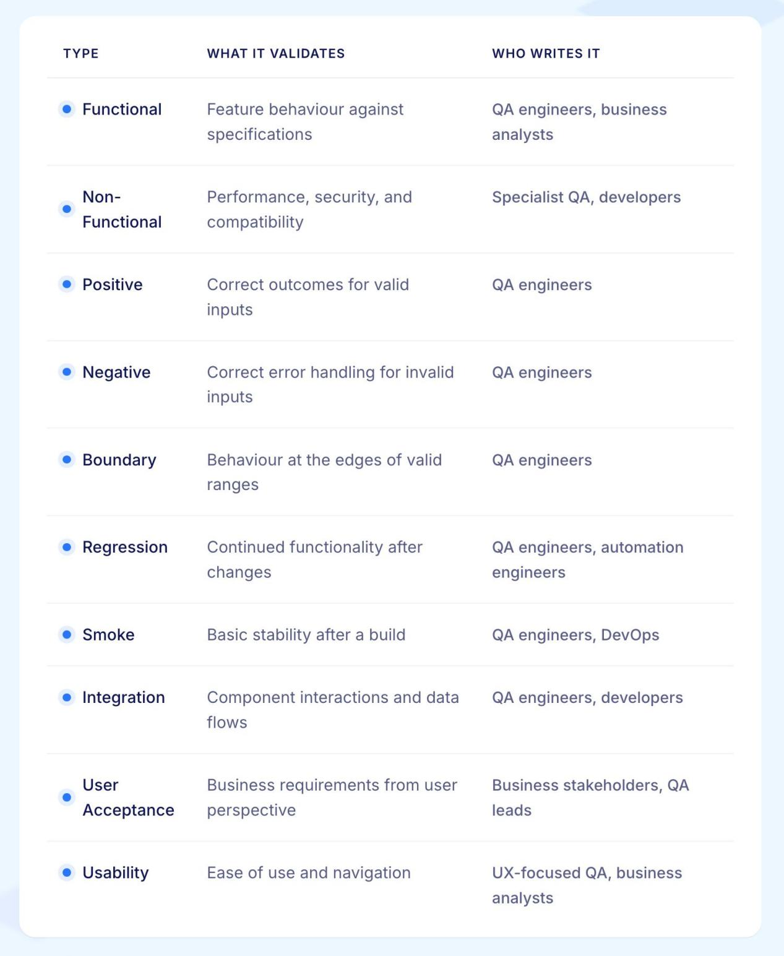

1. Functional Test Cases
Functional test cases verify that features behave according to their specifications. They are the most common type and form the backbone of any test suite. A functional test case for a login feature verifies that valid credentials produce a successful login, not that the page loads quickly or looks correct.

2. Non-Functional Test Cases
Non-functional test cases validate attributes like performance, security, usability, and compatibility rather than specific features. A performance test case might verify that a search results page loads within two seconds under a defined concurrent user load. These cases are distinct from functional ones because they measure quality characteristics rather than feature behaviour.

3. Positive Test Cases
Positive test cases use valid inputs to verify the system produces the expected correct outcome. They confirm the happy path works as intended. A positive test case for a registration form submits all required fields with valid data and verifies the account is created successfully.

4. Negative Test Cases
Negative test cases use invalid inputs to verify the system handles errors gracefully. They confirm the application rejects bad data with appropriate messages rather than crashing or producing unexpected behaviour. A negative test case for the same registration form submits an invalid email format and verifies the correct validation error appears.

5. Boundary Test Cases
Boundary test cases target the edges of valid input ranges, where defects cluster most frequently. For a field accepting passwords between 8 and 64 characters, boundary test cases verify behaviour at exactly 7, 8, 64, and 65 characters. These cases catch the off-by-one errors and incorrect comparison operators that functional testing routinely misses.

6. Regression Test Cases
Regression test cases verify that previously working functionality continues to work after a code change. They are executed after every significant change to confirm nothing that worked before has broken. Regression test cases form the core of automated test suites because they need to run repeatedly without modification.

7. Smoke Test Cases
Smoke test cases are a minimal subset of critical tests executed immediately after a build to confirm the application is stable enough for further testing. If smoke tests fail, testing stops and the build is rejected. They cover only the most fundamental functionality and execute quickly.

8. Integration Test Cases
Integration test cases verify that separate components work correctly together. Where unit tests validate components in isolation, integration test cases validate the interactions between them: data flowing correctly between services, APIs returning expected responses to the application, and database writes producing the correct state.

9. User Acceptance Test Cases
User acceptance test cases validate that the application meets business requirements from an end user's perspective. They are typically written and executed by business stakeholders or QA teams working from acceptance criteria rather than technical specifications. A UAT test case verifies a complete business workflow rather than an isolated feature.

10. Usability Test Cases
Usability test cases evaluate whether users can navigate and operate the application without difficulty or confusion. They assess clarity of error messages, discover-ability of features, accessibility of interactive elements, and overall ease of use rather than functional correctness.

Test Case vs Test Scenario vs Test Script
These three terms are used interchangeably in some teams and treated as completely distinct in others. Understanding the difference prevents miscommunication and ensures the right level of documentation is produced for each situation.
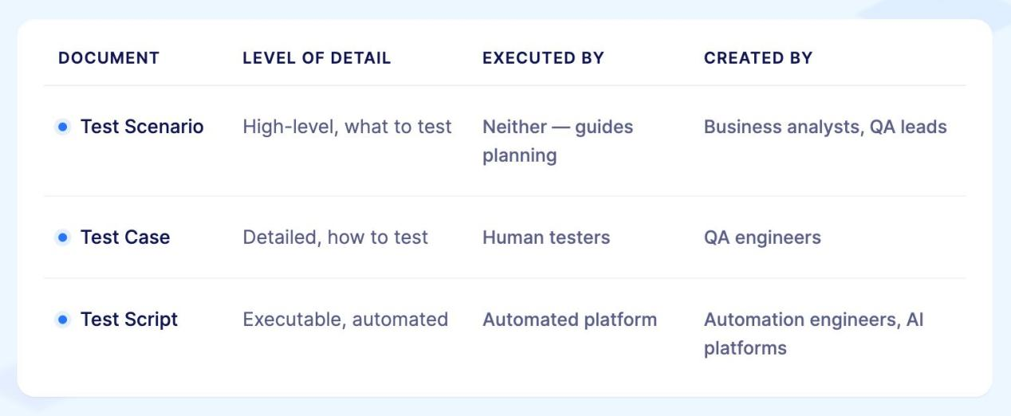

Test scenario
A test scenario is a high-level description of what needs to be validated. It describes the user goal or system behaviour being tested without specifying the exact steps.
"Verify that a user can log in to the application" is a test scenario. It tells you what to test, not how to test it. A single test scenario typically generates multiple test cases covering different conditions.

Test case
A test case is a detailed, specific implementation of a test scenario. It specifies the exact preconditions, step-by-step actions, test data, and expected results required to execute one particular validation.
"Verify that a user with valid credentials is redirected to the dashboard after clicking Sign In" is a test case derived from the login scenario. It tells you exactly what to do and what to look for.

Test script
A test script is an automated version of a test case written in a programming language or expressed in natural language for an AI-native platform. Where a test case describes what a human tester should do, a test script contains instructions that a machine can execute. A Selenium test script or a Virtuoso QA natural language journey is a test script. It automates the execution of the logic defined in the test case.

‍Test Case Components: Anatomy of Effective Test Cases
Well-structured test cases follow consistent formats ensuring clarity and completeness. Understanding each component enables writing test cases that others can execute reliably.

1. Test Case Identifier
Every test case requires unique identification enabling precise reference in test plans, defect reports, and traceability matrices. Identifiers typically follow patterns like TC001, REGRESSION_LOGIN_001, or MODULE_FEATURE_001, incorporating system, module, or feature context for clarity.

2. Test Case Title
Concise, descriptive titles immediately communicate what the test validates. Effective titles use action verbs and specify the exact scenario: "Verify successful user login with valid credentials," "Validate error message for invalid email format," "Confirm order total calculation with multiple discounts." Poor titles like "Login test" or "Test 1" provide insufficient context.

3. Test Description
Brief descriptions provide additional context beyond titles, explaining the test's purpose and what aspect of functionality it validates. For example: "This test verifies that users can successfully authenticate using registered email addresses and passwords, gaining access to their account dashboard upon successful login."

4. Preconditions
Preconditions specify the system state and data that must exist before test execution begins. "User account exists in database with email test@example.com and password Test123!," "Application is deployed to QA environment," "Test database contains sample product catalog," "User is logged out of the application."
Clearly defined preconditions ensure testers can establish appropriate starting conditions rather than encountering test failures due to improper setup.

5. Test Steps
Test steps provide sequential instructions for executing the test. Each step should be specific, actionable, and unambiguous. Rather than "Login to application," write "Navigate to login page at https://app.example.com/login, Enter 'test@example.com' in Email field, Enter 'Test123!' in Password field, Click 'Sign In' button."
Granular steps eliminate ambiguity. When tests fail, specific steps enable identifying exactly where execution diverged from expected behavior.

6. Test Data
Specify exact test data required for execution. "Email: test@example.com," "Password: Test123!," "Product SKU: WIDGET-001," "Discount Code: SAVE20." Documenting test data ensures reproducibility and enables maintaining test data separately from test steps for reusability.

7. Expected Results
Expected results define correct system behavior after executing each test step or at test completion. "User redirects to dashboard at https://app.example.com/dashboard," "Welcome message displays: 'Welcome back, John Doe'," "Session cookie sets with 24-hour expiration," "Last login timestamp updates in database."
Precise expected results enable objective pass/fail determination rather than subjective judgment about whether behavior seems correct.

8. Actual Results
During test execution, testers document actual observed behavior. When actual results match expected results, tests pass. Discrepancies indicate defects requiring investigation and remediation.

9. Test Status
Test cases maintain status throughout their lifecycle: Draft (being written), Ready for Review, Approved, Blocked (cannot execute due to dependencies), Pass (executed successfully), Fail (defect identified), Skip (not applicable for current release).

10. Priority and Severity
Priority indicates execution order and importance. Critical tests validate fundamental functionality like user authentication or payment processing. High priority tests cover major features. Medium and low priority tests address secondary functionality or edge cases.
Test case priority informs regression testing strategies when time constraints prevent executing complete test suites.

Writing Effective Manual Test Cases
Creating high-quality test cases requires systematic approaches ensuring completeness, clarity, and maintainability.
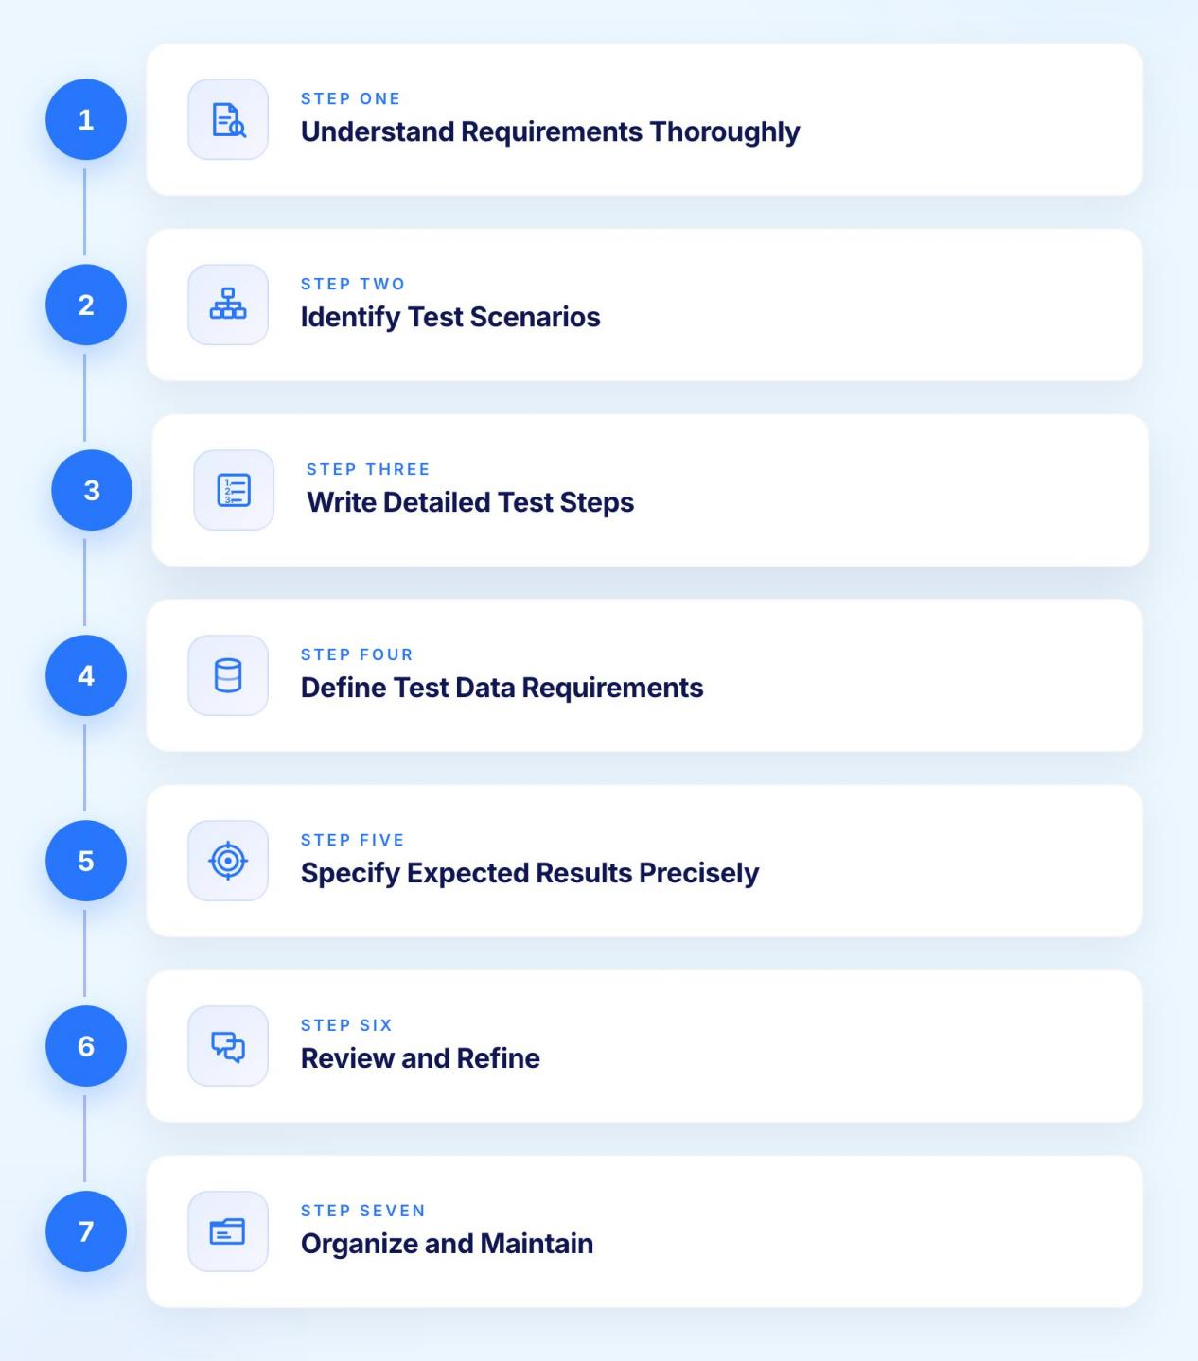

Step 1: Understand Requirements Thoroughly
Before writing test cases, achieve complete understanding of functionality being tested. Review requirements documents, user stories, acceptance criteria, design specifications, and prototypes. Clarify ambiguities with product owners and developers. Test cases can only validate functionality testers understand clearly.
For a user registration feature, understand: What information must users provide? What validation rules apply to each field? What happens after successful registration? What error messages display for invalid input? How does registration integrate with email verification?

Step 2: Identify Test Scenarios
Test scenarios represent high-level descriptions of what to test. For user registration: "User registers with valid information," "User attempts registration with existing email," "User submits form with invalid email format," "User leaves required fields empty," "User password fails complexity requirements."
Comprehensive scenario identification ensures test coverage across happy paths, error conditions, boundary cases, and integration points.

Step 3: Write Detailed Test Steps
Transform scenarios into specific, executable steps. The scenario "User registers with valid information" becomes:
Test Case: TC_REG_001 - Verify successful user registration with valid data
Preconditions: Application is accessible, test database is empty
Steps:
- Navigate to registration page at https://app.example.com/register
- Enter "John" in First Name field
- Enter "Doe" in Last Name field
- Enter "john.doe@example.com" in Email field
- Enter "SecurePass123!" in Password field
- Enter "SecurePass123!" in Confirm Password field
- Click "Register" button
‍
Expected Results:
- Registration success message displays: "Account created successfully! Please check your email to verify your account."
- User redirects to email verification pending page
- Verification email sends to john.doe@example.com
- Database contains new user record with status "pending verification"
‍

Step 4: Define Test Data Requirements
Document all test data needed for execution. For registration testing: valid names, valid email addresses, invalid email formats, weak passwords, strong passwords, special characters, boundary length values for each field.
Maintaining test data separately from test cases enables reusability and easier updates when data requirements change.

Step 5: Specify Expected Results Precisely
Vague expected results create interpretation ambiguity. Rather than "User should be able to register," specify exactly what success looks like: confirmation message text, navigation destination, email content, database state changes, API responses.
Precise expected results enable objective pass/fail determination and provide developers with clear defect reproduction steps when tests fail.

Step 6: Review and Refine
Peer review improves test case quality. Have teammates review test cases for clarity, completeness, and accuracy. Do steps make sense to someone unfamiliar with the feature? Are preconditions achievable? Are expected results verifiable? Does the test case actually validate what it claims to test?

Step 7: Organize and Maintain
Group test cases logically by feature, module, or user workflow. Maintain test suites for different testing types: smoke tests, regression tests, acceptance tests. Update test cases when requirements change, ensuring documentation remains accurate.

Best Practices for Manual Test Case Writing
Following established best practices improves test case quality, maintainability, and value.

1. Write for Clarity and Simplicity
Test cases should be understandable to anyone on the QA team, not just the author. Use simple, direct language. Avoid jargon unless it is standard terminology everyone understands. Each test case should validate one specific aspect of functionality rather than combining multiple unrelated tests.

2. Maintain Independence
Test cases should execute independently without depending on other test cases running first. Each test establishes its own preconditions rather than assuming a previous test left the system in a particular state. This independence enables parallel execution and reordering test sequences without breaks.

3. Include Negative Test Cases
Positive test cases verify systems work correctly with valid inputs. Negative test cases verify systems handle invalid inputs gracefully. Comprehensive testing requires both. For every valid input scenario, consider invalid alternatives: wrong data types, missing required fields, values outside acceptable ranges, boundary conditions.

4. Keep Test Cases Current
Test cases decay when applications evolve but documentation does not. Establish processes for updating test cases when requirements change, user interfaces are redesigned, or business logic updates. Outdated test cases waste execution time and create false defect reports.

5. Use Clear Naming Conventions
Consistent naming enables quick identification of test scope and purpose. Include module names, feature identifiers, and scenario types in test case IDs. "AUTH_LOGIN_VALID_001" immediately indicates authentication module, login feature, valid credentials scenario.

6. Document Assumptions
Make implicit assumptions explicit. If a test assumes browser cookies are enabled, document that assumption. If the test requires specific user permissions, state that explicitly. Documented assumptions prevent confusion when tests fail due to unmet preconditions.

Common Test Case Writing Mistakes to Avoid
Even experienced testers make mistakes that reduce test case effectiveness. Recognizing common pitfalls enables avoiding them.

1. Vague Test Steps
"Test the login functionality" provides no guidance about what to actually do. Specific steps like "Enter username, enter password, click submit button" enable consistent execution.

2. Missing Expected Results
Test cases specifying steps without expected results leave pass/fail determination to subjective judgment. Always document exactly what should happen at each critical step or at test completion.

3. Combining Multiple Scenarios
Test cases validating five different aspects of functionality in one long test become difficult to maintain and debug. When such tests fail, identifying which of the five scenarios actually failed requires investigation. Separate test cases for distinct scenarios improve clarity.

4. Assuming Knowledge
Test cases assuming testers know implicit details create execution inconsistencies. Document everything explicitly: which environment to use, where to find test data, what browser to use, what user role to authenticate with.

5. Neglecting Edge Cases
Testing only happy paths misses many defects. Include boundary value testing, negative scenarios, concurrent operations, and system limits in comprehensive test coverage.

6. Skipping Traceability
Test cases disconnected from requirements cannot prove coverage. Maintain clear links between test cases and the requirements, user stories, or acceptance criteria they validate.

Test Case Management Best Practices
Effective test case management requires appropriate tools and organizational practices beyond individual test case writing skills.

1. Version Control
Test cases should be version controlled alongside application code. Changes to test case documentation are tracked, previous versions can be retrieved if needed, multiple testers can collaborate without conflicts, and test case evolution aligns with application releases.

2. Test Suite Organization
Logical organization enables efficient test execution. Group test cases by module or feature area, priority level, testing type (smoke, regression, acceptance), and execution environment (dev, QA, staging).
Well-organized suites enable executing appropriate subsets for different scenarios: quick smoke tests after deployments, comprehensive regression before major releases, focused feature testing during development.

3. Coverage Analysis
Regular analysis of test coverage identifies gaps requiring additional test cases. Which requirements lack test cases? Which application modules have insufficient validation? What edge cases remain untested?
Coverage analysis informs test case writing priorities, ensuring testing effort focuses on areas with highest quality risk.

